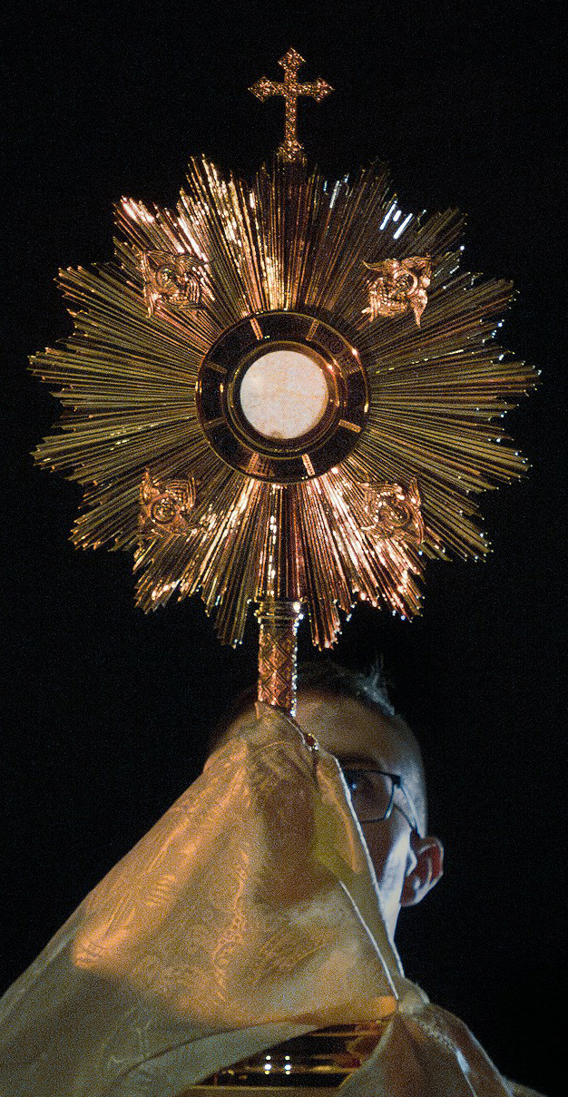
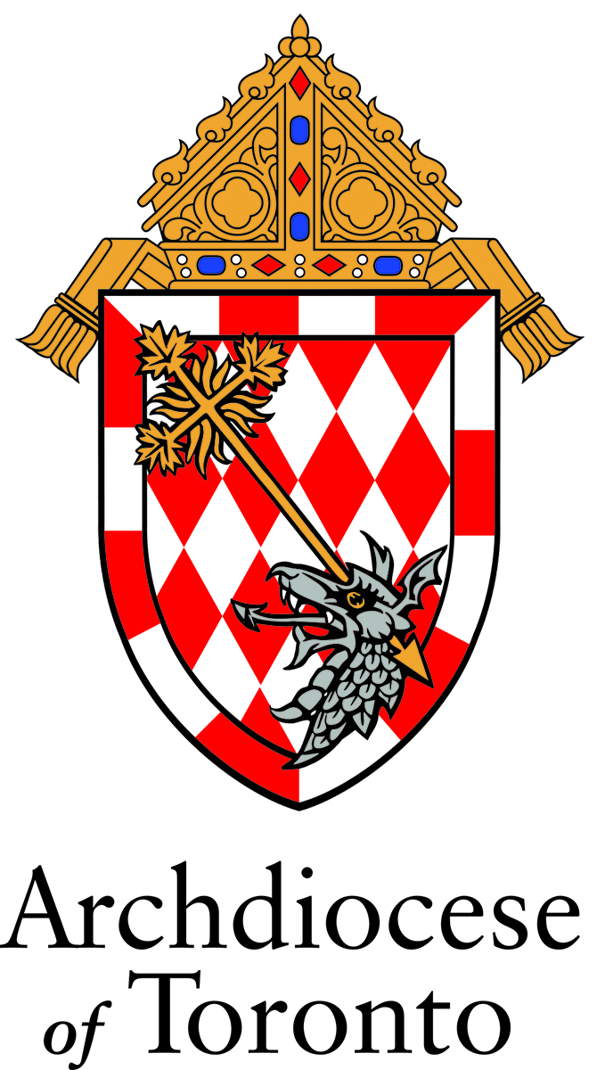
EUCHARISTIC
TRIDUUM
IN PREPARATION
FOR THE CELEBRATION OF THE SOLEMNITY OF THE MOST HOLY BODY AND BLOOD OF CHRIST IN THE ARCHDIOCESE OF TORONTO

EUCHARISTIC TRIDUUM Day 1

In the name of the Father, and of the Son, and of the Holy Spirit. Amen.

Come, let us adore Christ the Lord.
– The bread of life.

OPENING PRAYER

Let us pray.

Lord Jesus Christ,
you gave us the Eucharist
as the memorial of your suffering and death.
May our worship of this sacrament of your Body and Blood
help us to experience the salvation you won for us
and the peace of the kingdom
where you live and reign with the Father and the Holy Spirit,
God, for ever and ever. Amen.

WORD OF GOD Matthew 26.26 – 29

A reading from the holy Gospel according to Matthew.

Now as they were eating, Jesus took bread, and blessed, and broke it, and gave it to the disciples and said, “Take, eat; this is my body.” And he took a cup, and when he had given thanks he gave it to them, saying, “Drink of it, all of you; for this is my blood of the covenant, which is poured out for many for the forgiveness of sins. I tell you I shall not drink again of this fruit of the vine until that day when I drink it new with you in my Father’s kingdom.”

The Gospel of the Lord.

R. Praise to you, Lord Jesus Christ.

COMMENTARY – REFLECTION (optional)

Pope Leo XIV, excerpt from: Holy Mass, Procession to Saint Mary Major and Eucharistic Blessing on the Solemnity of the Most Holy Body and Blood of Christ: Homily of His Holiness Pope Leo XIV (22 June 2025)
Dear friends, Christ is God’s answer to our human hunger, because his Body is the bread of eternal life: Take this and eat of it, all of you! Jesus’ invitation reflects our daily experience: in order to remain alive, we need to nourish ourselves with life, drawing it from plants and animals. Yet eating something dead reminds us that we too, no matter how much we eat, will one day die. On the other hand, when we partake of Jesus, the living and true Bread, we live for him. By offering himself completely, the crucified and risen Lord delivers himself into our hands, and we realize that we were made to partake of God. Our hungry nature bears the mark of a need that is satisfied by the grace of the Eucharist. As Saint Augustine writes, Christ is truly “panis qui reficit, et non deficit; panis qui sumi potest, consumi non potest” (Serm. 130, 2): he is bread that restores and does not run short; bread that can be eaten but not exhausted. The Eucharist, in fact, is the true, real, and substantial presence of the Saviour (cf. Catechism of the Catholic Church, 1413), who transforms bread into himself in order to transform us into himself. Living and life-giving, the Corpus Domini makes us, the Church herself, the Body of the Lord.
For this reason, echoing the Apostle Paul (cf. 1 Cor 10:17), the Second Vatican Council teaches that “in the sacrament of the Eucharistic bread, the unity of believers, who form one body in Christ, is both expressed and achieved. All are called to this union with Christ, who is the light of the world, from whom we come, through whom we live, and towards whom we direct our lives” (Dogmatic Constitution Lumen Gentium, 3). The procession that we are about to undertake is a sign of that journey. Together, as shepherds and flock, we will feed on the Blessed Sacrament, adore him and carry him through the streets. In doing so, we will present him before the eyes, the consciences and the hearts of the people. To the hearts of those who believe, so that they may believe more firmly; to the hearts of those who do not believe, so that they may reflect on the hunger present within them and the bread that alone can satisfy it.
Strengthened by the food that God gives us, let us bring Jesus to the hearts of all, because Jesus involves everyone in his work of salvation by calling each of us to sit at his table. Blessed are those who are called, for they become witnesses of this love!

LITANY OF THE MOST BLESSED SACRAMENT

Lord, have mercy, Lord, have mercy.
Christ, have mercy, Christ, have mercy.
Lord, have mercy, Lord, have mercy.

God the Father of Heaven, have mercy on us.
God the Son, Redeemer of the world, have mercy on us.
God, the Holy Spirit, have mercy on us.
Holy Trinity, One God, have mercy on us.

Living Bread, who from heaven descended, have mercy on us.
Hidden God and Savior, have mercy on us.
Grain of the elect, have mercy on us.
Holy Sacrifice, have mercy on us.
Living Sacrifice, have mercy on us.
Sacrifice pleasing to God, have mercy on us.

Food of angels, have mercy on us.
Hidden manna, have mercy on us.
Spotless oblation, have mercy on us.
Perpetual sacrifice, have mercy on us.
Lamb without spot, have mercy on us.
Purest Feast, have mercy on us.
Our food and guest, have mercy on us.
Cup of blessing, have mercy on us.
Offeror and offering, have mercy on us.
Mystery of faith, have mercy on us.
Sacrament of holiness, have mercy on us.
Bond of love, have mercy on us.
Memory of God's wonders, have mercy on us.
Supersubstantial Bread, have mercy on us.
Bloodless sacrifice, have mercy on us.
Most Holy and most august Mystery, have mercy on us.
Divine medicine of immortality, have mercy on us.
Most powerful aid of grace, have mercy on us.

Most high and venerable Sacrament, have mercy on us.
Most holy of all sacrifices, have mercy on us.
Word made flesh, living in us, have mercy on us.
Heavenly antidote, by which we are preserved
from sin, have mercy on us.
Most holy Commemoration of the Passion of
Our Lord, have mercy on us.
Most stupendous of all miracles, have mercy on us.

Gift transcending all abundance, have mercy on us.
Most high memorial of divine love, have mercy on us.
Infinite Divine Treasure of God, have mercy on us.
Awesome and life-giving Sacrament, have mercy on us.
Refreshment of holy souls, have mercy on us.
Sweetest banquet at which the Angels serve, have mercy on us.

True propitiatory Sacrifice for the living
and the dead, have mercy on us.
Viaticum of those dying in the Lord, have mercy on us.
Pledge of future glory, have mercy on us.

Be merciful, deliver us, O Lord.
From the unworthy reception of
Your Body and Blood, deliver us, O Lord.
From the concupiscence of the flesh, deliver us, O Lord.
From the concupiscence of the eyes, deliver us, O Lord.
From pride, deliver us, O Lord.
From every occasion of sin, deliver us, O Lord.

Through that desire, with which You desired to eat
the Passover with Your disciples, deliver us, O Lord.
Through that profound humility with which You
washed Your disciples' feet, deliver us, O Lord.
Through that most ardent love, with which You
instituted this Divine Sacrament, deliver us, O Lord.
Through Your most precious Blood, which You have
left for us upon the altar, deliver us, O Lord.
Through those five wounds of Your most holy Body,
which You have given up for us, deliver us, O Lord.

We Sinners, we beseech You, hear us.
That You would deem worthy to preserve and
increase the faith, reverence, and devotion in us
towards this admirable Sacrament, we beseech You, hear us.
That You would deem worthy to lead us through the
true confession of our sins to a frequent reception of
the Eucharist, we beseech You, hear us.
That You would deem worthy to free us
from every heresy, falsehood,
and blindness of the heart, we beseech You, hear us.
That You would deem worthy to
impart to us the heavenly and precious
fruits of this most Holy Sacrament, we beseech You, hear us.
That You would deem worthy to
protect and strengthen us in our hour of
death with this heavenly viaticum, we beseech You, hear us.
Jesus Son of God, we beseech You, hear us.

Christ, hear us, Christ, hear us.
Christ, graciously hear us, Christ, graciously hear us.

Lamb of God, who take away the
sins of the world, spare us, O Lord.
Lamb of God, who take away the
sins of the world, graciously hear us, O Lord.
Lamb of God, who take away the
sins of the world, have mercy on us, O Lord.

Let us pray.

O God, who under a marvelous Sacrament
has left us a memorial of Your Passion,
grant us, so to venerate the sacred mysteries of Your Body and Blood,
that we may ever perceive within us the fruit of Your redemption,
Who lives and reigns forever and ever. Amen.

ANIMA CHRISTI

Soul of Christ, sanctify me.
Body of Christ, heal me.
Blood of Christ, drench me.
Water from the side of Christ, wash me.
Passion of Christ, strengthen me.
Good Jesus, hear me.
In your wounds shelter me.
From turning away keep me.
From the evil one protect me.
At the hour of my death call me.
Into your presence lead me,
to praise you with all your saints
for ever and ever. Amen.

CLOSING PRAYER

Grant, almighty God,
that, just as we are renewed
by the Supper of your Son in this present age,
so we may enjoy his banquet for all eternity.
Who lives and reigns for ever and ever. Amen.

In the name of the Father, and of the Son, and of the Holy Spirit. Amen.

EUCHARISTIC TRIDUUM Day 2

In the name of the Father, and of the Son, and of the Holy Spirit. Amen.

You have given them Bread from Heaven.
– Having all sweetness within it.

OPENING PRAYER

Remember your mercies, O Lord,
and with your eternal protection sanctify your servants,
for whom Christ your Son,
by the shedding of his Blood,
established the Paschal Mystery.
Who lives and reigns for ever and ever. Amen.

WORD OF GOD Luke 24.28 – 35

A reading from the holy Gospel according to Luke.

As they came near the village to which they were going, he walked ahead as if he were going on. But they urged him strongly, saying, “Stay with us, because it is almost evening and the day is now nearly over.” So he went in to stay with them. When he was at the table with them, he took bread, blessed and broke it, and gave it to them. Then their eyes were opened, and they recognized him; and he vanished from their sight. They said to each other, “Were not our hearts burning within us while he was talking to us on the road, while he was opening the scriptures to us?” That same hour they got up and returned to Jerusalem; and they found the eleven and their companions gathered together. They were saying, “The Lord has risen indeed, and he has appeared to Simon!” Then they told what had happened on the road, and how he had been made known to them in the breaking of the bread.

The Gospel of the Lord.

R. Praise to you, Lord Jesus Christ.

COMMENTARY – REFLECTION (optional)

Pope Francis, excerpt from: Holy Mass, Procession to Saint Mary Major and Eucharistic Blessing on the Solemnity of the Most Holy Body and Blood of Christ: Homily of His Holiness Pope Francis (26 May 2016)

“Do this in remembrance of me” (1 Cor 11 :24-25).

Twice the Apostle Paul, writing to the community in Corinth, recalls this command of Jesus in his account of the institution of the Eucharist. It is the oldest testimony we have to the words of Christ at the Last Supper.

“Do this”. That is, take bread, give thanks and break it; take the chalice, give thanks, and share it. Jesus gives the command to repeat this action by which he instituted the memorial of his own Pasch, and in so doing gives us his Body and his Blood. This action reaches us today: it is the “doing” of the Eucharist which always has Jesus as its subject, but which is made real through our poor hands anointed by the Holy Spirit.

Breaking: this is the other word explaining the meaning of those words: “Do this in remembrance of me”. Jesus was broken; he is broken for us. And he asks us to give ourselves, to break ourselves, as it were, for others. This “breaking bread” became the icon, the sign for recognizing Christ and Christians. We think of Emmaus: they knew him “in the breaking of the bread” (Lk 24:35). We recall the first community of Jerusalem: “They held steadfastly… to the breaking of the bread” (Acts 2:42). From the outset it is the Eucharist which becomes the centre and pattern of the life of the Church. But we think also of all the saints – famous or anonymous – who have “broken” themselves, their own life, in order to “give something to eat” to their brothers and sisters. How many mothers, how many fathers, together with the slices of bread they provide each day on the tables of their homes, have broken their hearts to let their children grow, and grow well! How many Christians, as responsible citizens, have broken their own lives to defend the dignity of all, especially the poorest, the marginalized and those discriminated! Where do they find the strength to do this? It is in the Eucharist: in the power of the Risen Lord’s love, who today too breaks bread for us and repeats: “Do this in remembrance of me”.

May this action of the Eucharistic procession, which we will carry out shortly, respond to Jesus’ command. An action to commemorate him; an action to give food to the crowds of today; an act to break open our faith and our lives as a sign of Christ’s love for this city and for the whole world.

LITANY OF THE MOST PRECIOUS BLOOD OF JESUS

Lord, have mercy, Lord, have mercy.
Christ, have mercy, Christ, have mercy.
Lord, have mercy, Lord, have mercy.
Christ, hear us, Christ, hear us.
Christ, graciously hear us, Christ, graciously hear us.

God our Father in heaven, have mercy on us.
God the Son, Redeemer of the world, have mercy on us.
God the Holy Spirit, have mercy on us.
Holy Trinity, one God, have mercy on us.

Blood of Christ, only Son of the Father, save us.
Blood of Christ, incarnate Word, save us.
Blood of Christ, of the new and eternal covenant, save us.
Blood of Christ, that spilled to the ground, save us.
Blood of Christ, that flowed at the scourging, save us.
Blood of Christ, dripping from the thorns, save us.
Blood of Christ, shed on the cross, save us.
Blood of Christ, the price of our redemption, save us.
Blood of Christ, our only claim to pardon, save us.
Blood of Christ, our blessing cup, save us.
Blood of Christ, in which we are washed, save us.
Blood of Christ, torrent of mercy, save us.
Blood of Christ, that overcomes evil, save us.
Blood of Christ, strength of the martyrs, save us.
Blood of Christ, endurance of the saints, save us.
Blood of Christ, that makes the barren fruitful, save us.
Blood of Christ, protection of the threatened, save us.
Blood of Christ, comfort of the weary, save us.
Blood of Christ, solace of the mourner, save us.
Blood of Christ, hope of the repentant, save us.
Blood of Christ, consolation of the dying, save us.
Blood of Christ, our peace and refreshment, save us.
Blood of Christ, our pledge of life, save us.
Blood of Christ, by which we pass to glory, save us.
Blood of Christ, most worthy of honor, save us.

Lamb of God, you take away the sins of the world, spare us, O Lord.
Lamb of God, you take away the sins of the world, graciously hear us, O Lord.

Lamb of God, you take away the sins of the world, have mercy on us.
You have redeemed us, O Lord, in your Blood. And made for us, Our God,
a kingdom.
Let us pray:

Almighty and eternal God,
you have appointed your Only Begotten Son the Redeemer of the world,
and willed to be appeased by his Blood.
Grant, we beg of you, that we may worthily adore this price of our salvation,
and through its power be safeguarded from the evils of the present life,
so that we may rejoice in its fruits forever in heaven.
Through the same Christ our Lord. Amen.

ANIMA CHRISTI

Soul of Christ, sanctify me.
Body of Christ, heal me.
Blood of Christ, drench me.
Water from the side of Christ, wash me.
Passion of Christ, strengthen me.
Good Jesus, hear me.
In your wounds shelter me.
From turning away keep me.
From the evil one protect me.
At the hour of my death call me.
Into your presence lead me,
to praise you with all your saints
for ever and ever. Amen.

CLOSING PRAYER

O God, who by the Precious Blood of your
Only Begotten Son
have redeemed the whole world,
preserve in us the work of your mercy,
so that, ever honouring the mystery of our salvation,
we may merit to obtain its fruits.
Through our Lord Jesus Christ, your Son,
who lives and reigns with you in the unity of the Holy Spirit,
God, for ever and ever. Amen.

In the name of the Father, and of the Son, and of the Holy Spirit. Amen.

EUCHARISTIC TRIDUUM Day 3

In the name of the Father, and of the Son, and of the Holy Spirit. Amen.

You gave them bread from heaven to be their food,
– And this bread contained all goodness.

OPENING PRAYER

Lord Jesus Christ,
we worship you living among us
in the sacrament of your body and blood.
May we offer to our Father in heaven
a solemn pledge of undivided love.
May we offer to our brothers and sisters
a life poured out in loving service of that kingdom
where you live with the Father and the Holy Spirit,
God for ever and ever. Amen.

WORD OF GOD John 6.51 – 58

A reading from the holy Gospel according to John.

I am the living bread that came down from heaven. Whoever eats of this bread will live forever; and the bread that I will give for the life of the world is my flesh.”

The Jews then disputed among themselves, saying, “How can this man give us his flesh to eat?” So Jesus said to them, “Very truly, I tell you, unless you eat the flesh of the Son of Man and drink his blood, you have no life in you. Those who eat my flesh and drink my blood have eternal life, and I will raise them up on the last day; for my flesh is true food and my blood is true drink. Those who eat my flesh and drink my blood abide in me, and I in them. Just as the living Father sent me, and I live because of the Father, so whoever eats me will live because of me. This is the bread that came down from heaven, not like that which your ancestors ate, and they died. But the one who eats this bread will live forever.”

The Gospel of the Lord.

R. Praise to you, Lord Jesus Christ.

COMMENTARY – REFLECTION (optional)

Pope Benedict XVI, excerpt from: General Audience (17 November 2010)

“This morning too I would like to introduce a female figure to you. She is little known but the Church is deeply indebted to her, not only because of the holiness of her life but also because, with her great fervour, she contributed to the institution of one of the most important solemn Liturgies of the year: Corpus Christi.” She is St Juliana de Cornillon, also known as St Juliana of Liège, born around 1191.

Juliana “had a profound sense of Christ’s presence, which she experienced by living the Sacrament of the Eucharist especially intensely and by pausing frequently to meditate upon Jesus’ words: “And lo, I am with you always, to the close of the age” (Mt 28:20). At age 16 she had a vision of “a feast in which believers would be able to adore the Eucharist so as to increase in faith, to advance in the practice of the virtues and to make reparation for offences to the Most Holy Sacrament.” She kept the vision secret for about 20 years and “continued zealously for Eucharistic worship.”

After initial hesitation, her bishop “accepted the proposal of Juliana and her companions and first introduced the Solemnity of Corpus Christi in his diocese. Later other Bishops following his example instituted this Feast in the territories entrusted to their pastoral care.” Years later, in 1264, Pope Urban IV, instituted the Solemnity of Corpus Christi for the universal Church. He said, “Although the Eucharist is celebrated solemnly every day, we deem it fitting that at least once a year it be celebrated with greater honour and a solemn commemoration. “Indeed we grasp the other things we commemorate with our spirit and our mind, but this does not mean that we obtain their real presence. On the contrary, in this sacramental commemoration of Christ, even though in a different form, Jesus Christ is present with us in his own substance. While he was about to ascend into Heaven he said ‘And lo, I am with you always, to the close of the age’ (Matthew 28:20)”.

“The Pontiff made a point of setting an example by celebrating the solemnity of Corpus Christi in Orvieto, the town where he was then residing. Indeed, he ordered that the famous Corporal with the traces of the Eucharistic miracle which had occurred in Bolsena the previous year, 1263, be kept in Orvieto Cathedral — where it still is today.

While a priest was consecrating the bread and the wine he was overcome by strong doubts about the Real Presence of the Body and Blood of Christ in the sacrament of the Eucharist. A few drops of blood began miraculously to ooze from the consecrated Host, thereby confirming what our faith professes.”

“I would like to affirm with joy that today there is a “Eucharistic springtime” in the Church: How many people pause in silence before the Tabernacle to engage in a loving conversation with Jesus! It is comforting to know that many groups of young people have rediscovered the beauty of praying in adoration before the Most Blessed Sacrament.”

“In remembering St Juliana of Cornillon let us also renew our faith in the Real Presence of Christ in the Eucharist. As we are taught by the Compendium of the Catechism of the Catholic Church, “Jesus Christ is present in the Eucharist in a unique and incomparable way. He is present in a true, real and substantial way, with his Body and his Blood, with his Soul and his Divinity. In the Eucharist, therefore, there is present in a sacramental way, that is, under the Eucharistic Species of bread and wine, Christ whole and entire, God and Man” (n. 282).”

LITANY OF THE HOLY EUCHARIST

Lord, have mercy, Lord, have mercy.
Christ, have mercy, Christ, have mercy.
Lord, have mercy, Lord, have mercy.

Jesus, the Most High, have mercy on us.
Jesus, the holy One, have mercy on us.
Jesus, Word of God, have mercy on us.
Jesus, only Son of the Father, have mercy on us.
Jesus, Son of Mary, have mercy on us.
Jesus, crucified for us, have mercy on us.
Jesus, risen from the dead, have mercy on us.
Jesus, reigning in glory, have mercy on us.
Jesus, coming in glory, have mercy on us.

Jesus, our Lord, have mercy on us.
Jesus, our hope, have mercy on us.
Jesus, our peace, have mercy on us.
Jesus, our Savior, have mercy on us.
Jesus, our salvation, have mercy on us.
Jesus, our resurrection, have mercy on us.

Jesus, Judge of all, have mercy on us.
Jesus, Lord of the Church, have mercy on us.
Jesus, Lord of creation, have mercy on us.
Jesus, Lover of all, have mercy on us.
Jesus, life of the world, have mercy on us.
Jesus, freedom for the imprisoned, have mercy on us.
Jesus, joy of the sorrowing, have mercy on us.
Jesus, giver of the Spirit, have mercy on us.
Jesus, giver of good gifts, have mercy on us.
Jesus, source of new life, have mercy on us.
Jesus, Lord of life, have mercy on us.
Jesus, eternal high priest, have mercy on us.
Jesus, priest and victim, have mercy on us.
Jesus, true Shepherd, have mercy on us.
Jesus, true light, have mercy on us.

Jesus, bread of heaven, have mercy on us.
Jesus, bread of life, have mercy on us.
Jesus, bread of thanksgiving, have mercy on us.
Jesus, life-giving bread, have mercy on us.
Jesus, holy manna, have mercy on us.

Jesus, new covenant, have mercy on us.
Jesus, food for everlasting life, have mercy on us.
Jesus, food for our journey, have mercy on us.
Jesus, holy banquet, have mercy on us.
Jesus, true sacrifice, have mercy on us.
Jesus, perfect sacrifice, have mercy on us.
Jesus, eternal sacrifice, have mercy on us.
Jesus, divine Victim, have mercy on us.
Jesus, Mediator of the new covenant, have mercy on us.
Jesus, mystery of the altar, have mercy on us.
Jesus, mystery of faith, have mercy on us.
Jesus, medicine of immortality, have mercy on us.
Jesus, pledge of eternal glory, have mercy on us.

Jesus, Lamb of God, you take away
the sins of the world: have mercy on us.
Jesus, Bearer of our sins, you take
away the sins of the world: have mercy on us.
Jesus, Redeemer of the world, you
take away the sins of the world: have mercy on us.

Christ, hear us, Christ, hear us.
Christ, graciously hear us, Christ, graciously hear us.
Lord Jesus, hear our prayer, Lord Jesus, hear our prayer.

ANIMA CHRISTI

Soul of Christ, sanctify me.
Body of Christ, heal me.
Blood of Christ, drench me.
Water from the side of Christ, wash me.
Passion of Christ, strengthen me.
Good Jesus, hear me.
In your wounds shelter me.
From turning away keep me.
From the evil one protect me.
At the hour of my death call me.
Into your presence lead me,
to praise you with all your saints
for ever and ever. Amen.

CLOSING PRAYER

O God, who have accomplished the work of human redemption through the Paschal Mystery of your Only Begotten Son,
graciously grant that we, who confidently proclaim,
under sacramental signs, the Death and Resurrection of Christ,
may experience continued increase of your saving grace.

Through our Lord Jesus Christ, Your Son,
who lives and reigns with you in the unity of the Holy Spirit,
God, for ever and ever. Amen.

In the name of the Father, and of the Son, and of the Holy Spirit. Amen.

Acknowledgements

Excerpts from the English translation of The Liturgy of the Hours © 1973, 1974, 1975, International Commission on English in the Liturgy Corporation (ICEL); excerpts from the English translation of Holy Communion & Worship of the Eucharist Outside Mass © 1974, ICEL; excerpts from the English translation of The Roman Missal © 2010, ICEL. All rights reserved. © Concacan Inc., 2011 for the Canadian Edition. All rights reserved.
Scripture quotations contained herein are extracted from the New Revised Standard Version: Catholic Edition. © 1989, 1993 by the Division of Christian Education of the National Council of Churches of Christ in the United States of America. All rights reserved.

Excerpt from the Fourth Edition of the Enchiridion Indulgentiarum. July 16, 1999. © L’Osservatore Romano, 1999.

Excerpt from the homily of Benedict XVI. Mass and Eucharistic Procession on the Solemnity of Corpus Domini. Sunday, May 26, 2005. © Libreria Editrice Vaticana, 2005.

Excerpt from Benedict XVI. General Audience, November 17, 2010. © Libreria Editrice Vaticana, 2010.

The Rites of the Catholic Church Volume One. © 1990 The Liturgical Press, Collegeville, MN. All rights reserved.

“Litany of the Most Blessed Sacrament.” Decree Prot. N. 1050/11/L. Congregation for Divine Worship and the Discipline of the Sacraments. May 30, 2013. Translation by Archdiocese of Toronto.

“Litany of the Holy Eucharist.” Copyright © 1993 United States Conference of Catholic Bishops, Washington, DC. All rights reserved.

Excerpt from the homily of Francis. Mass, Procession to Saint Mary Major and Eucharistic Blessing on the Solemnity of the Most Holy Body and Blood of Christ. Sunday, May 26, 2016. © Libreria Editrice Vaticana, 2016.

